**This is how you can structure your NFT wallets**

The entire NFT market is very vulnerable to scammers and hackers.

You may have heard of someone just entering an incorrect web address that looked almost identical to the one you tried to connect your wallet to. One wrong click and it can happen that all your NFTs are stolen.

**Example:**

www.veefriends.com is the original adress. But if you type one wrong ending for example [www.veefriends.ne](http://www.veefriends.ne) instead of com it is a scam adress.. Just one wrong ending and you click the link, connect your metamask to the address and you lose all your NFTs and cryptocurrencies on it.

For this reason it makes sense to create several NFT wallets. You can do this, for example, with Metamask with multiple accounts that you switch between.

**Exemplary structuring of NFT wallets.**

**1 . one Wallet as the main wallet for storing your NFTs**

possibly with hard wallet as sub-wallet for storing valuable NFTS (see picture)

**2. one Wallet for mints** (If you want to mint NFTs. There is always a great danger that you will be directed to fake sites. Therefore, a wallet for mints to be on the safe side)

**3. one Wallet for trash** (If you get free airdrops and for projects that may not be going so well)

In the picture you can see what the different accounts at Metamask look like and you can easily switch between the accounts.

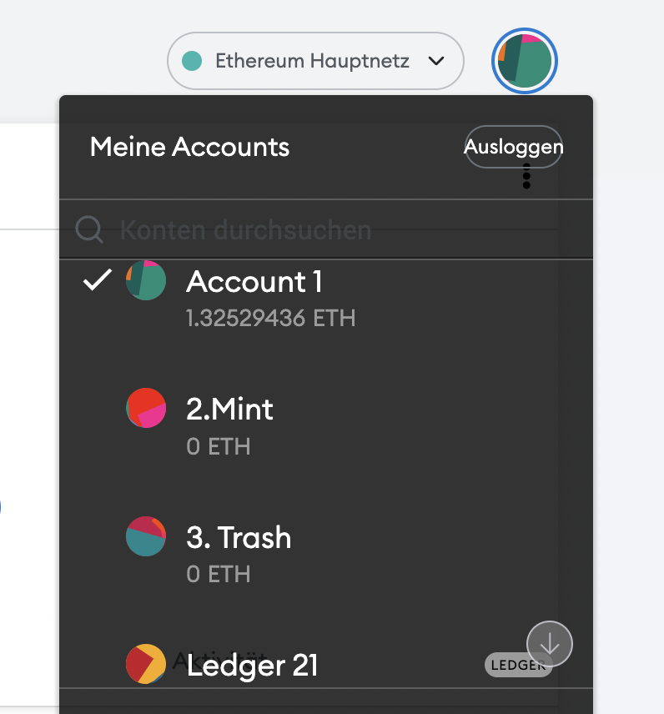

Before you start investing in NFTs, plan and create your wallet strategy.